Problem Solving and testing using Java

WEEK 4

Course code:10211CS227

V.NEELA DEVI

VTU28589
Task1:https://leetcode.com/problems/determine-if-string-halves-are-alike/
Code:
class Solution {
public boolean halvesAreAlike(String s) {
int n = s.length();
int countA = 0;
int countB = 0;
for (int i = 0; i < n / 2; i++) {
if (isVowel(s.charAt(i))) {
countA++;
}
}

for (int i = n / 2; i < n; i++) {
if (isVowel(s.charAt(i))) {
countB++;
}
}

return countA == countB;
}

private boolean isVowel(char c) {
return c == 'a' || c == 'e' || c == 'i' ||
c == 'o' || c == 'u' ||
c == 'A' || c == 'E' || c == 'I' ||
c == 'O' || c == 'U';
}
}
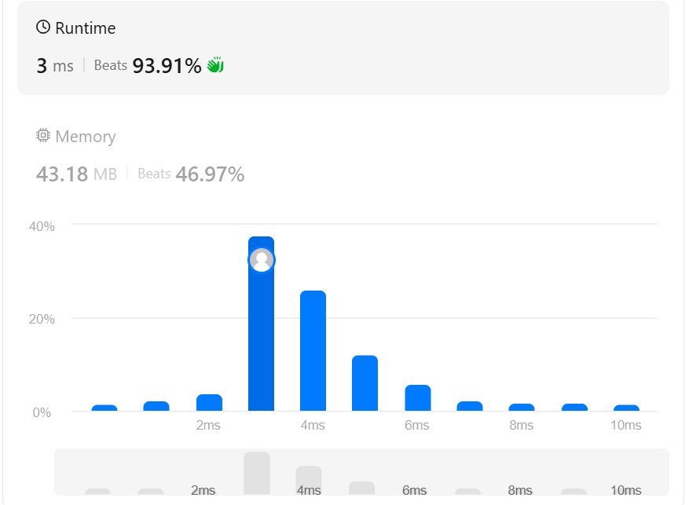
Task2:https://www.codechef.com/problems/LAPIN
Code:
import java.util.Arrays;
import java.util.Scanner;

public class Main {
public static void main(String[] args) {
Scanner sc = new Scanner(System.in);
if (!sc.hasNextInt()) return;

int T = sc.nextInt();
while (T-- > 0) {
String s = sc.next();
int n = s.length();

int[] leftFreq = new int[26];
int[] rightFreq = new int[26];

int half = n / 2;
int rightStart = (n % 2 == 0) ? half : half + 1;

for (int i = 0; i < half; i++) {
leftFreq[s.charAt(i) - 'a']++;
}
for (int i = rightStart; i < n; i++) {
rightFreq[s.charAt(i) - 'a']++;
}

if (Arrays.equals(leftFreq, rightFreq)) {
System.out.println("YES");
} else {
System.out.println("NO");
}
}
sc.close();
}
}
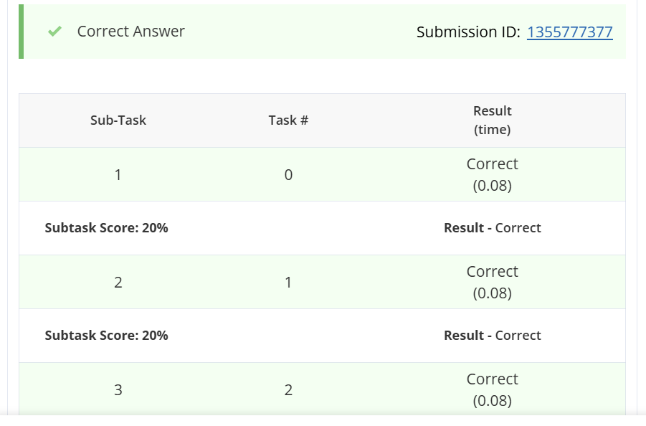

Task3:https://www.hackerrank.com/challenges/compare-the-triplets/problem
Code:
import java.util.*;

public class Solution {

public static void main(String[] args) {
Scanner sc = new Scanner(System.in);

int[] a = new int[3];
int[] b = new int[3];

for (int i = 0; i < 3; i++) {
a[i] = sc.nextInt();
}

for (int i = 0; i < 3; i++) {
b[i] = sc.nextInt();
}

int alice = 0;
int bob = 0;

for (int i = 0; i < 3; i++) {
if (a[i] > b[i]) {
alice++;
} else if (a[i] < b[i]) {
bob++;
}
}

System.out.println(alice + " " + bob);
}
}
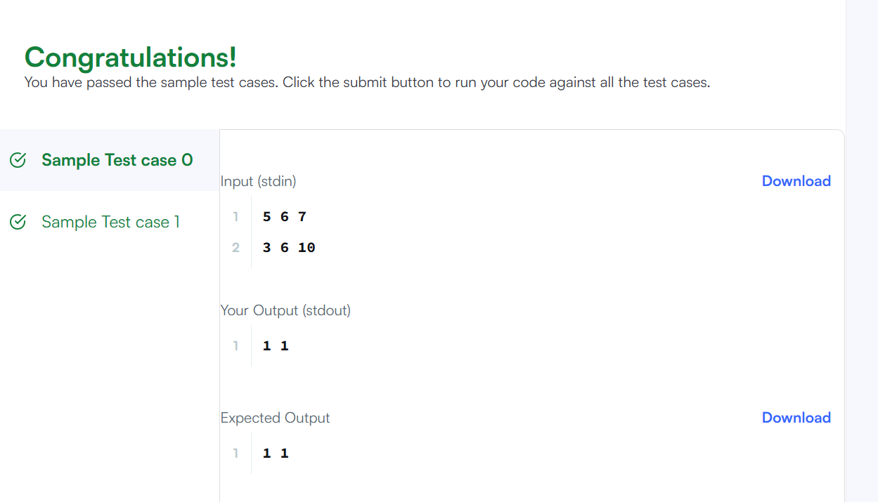
Task4:https://leetcode.com/problems/contains-duplicate/
Code:
import java.util.HashSet;
import java.util.Set;

class Solution {
public boolean containsDuplicate(int[] nums) {
Set<Integer> seen = new HashSet<>();

for (int num : nums) {
// If the element is already present, a duplicate is found
if (!seen.add(num)) {
return true;
}
}

return false;
}
}
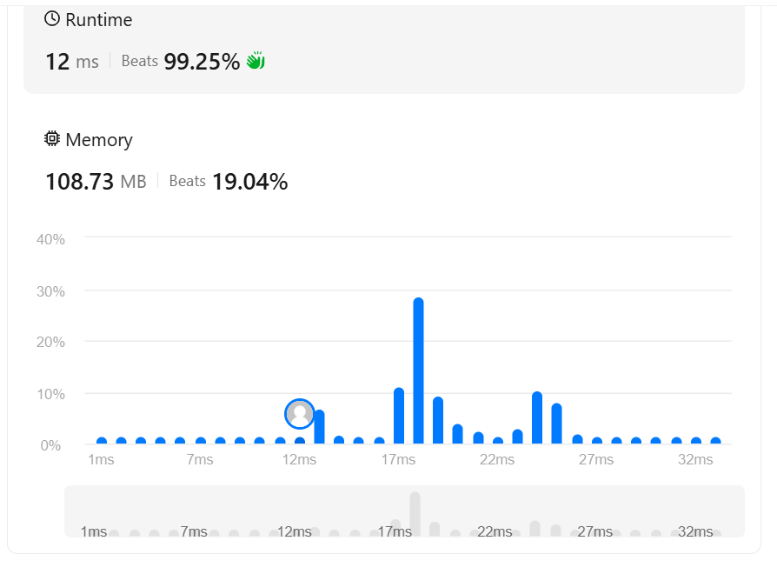
Task5:https://www.hackerrank.com/challenges/time-conversion/problem

Code:
import java.io.*;
import java.util.*;

public class Solution {

public static String timeConversion(String s) {
String modifier = s.substring(s.length() - 2);
int hour = Integer.parseInt(s.substring(0, 2));
String restOfTime = s.substring(2, s.length() - 2);

if (modifier.equals("AM")) {
if (hour == 12) {
hour = 0;
}
} else {
if (hour != 12) {
hour += 12;
}
}

return String.format("%02d%s", hour, restOfTime);
}

public static void main(String[] args) {
Scanner sc = new Scanner(System.in);
if (sc.hasNextLine()) {
String s = sc.nextLine().trim();
System.out.println(timeConversion(s));
}
sc.close();
}
}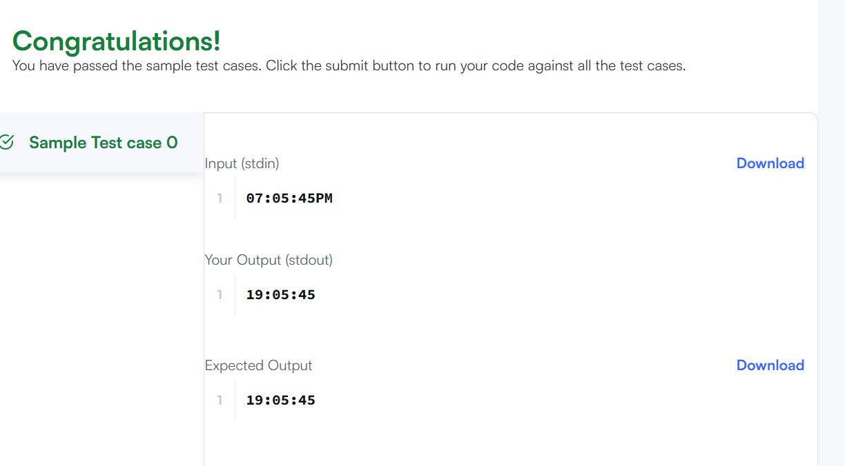

Task6:https://leetcode.com/problems/move-zeroes/
Code:
public class Solution {
public void moveZeroes(int[] nums) {
int insertPos = 0;

// Shift all non-zero elements forward
for (int i = 0; i < nums.length; i++) {
if (nums[i] != 0) {
nums[insertPos] = nums[i];
insertPos++;
}
}

// Fill the remaining array with zeroes
while (insertPos < nums.length) {
nums[insertPos] = 0;
insertPos++;
}
}
}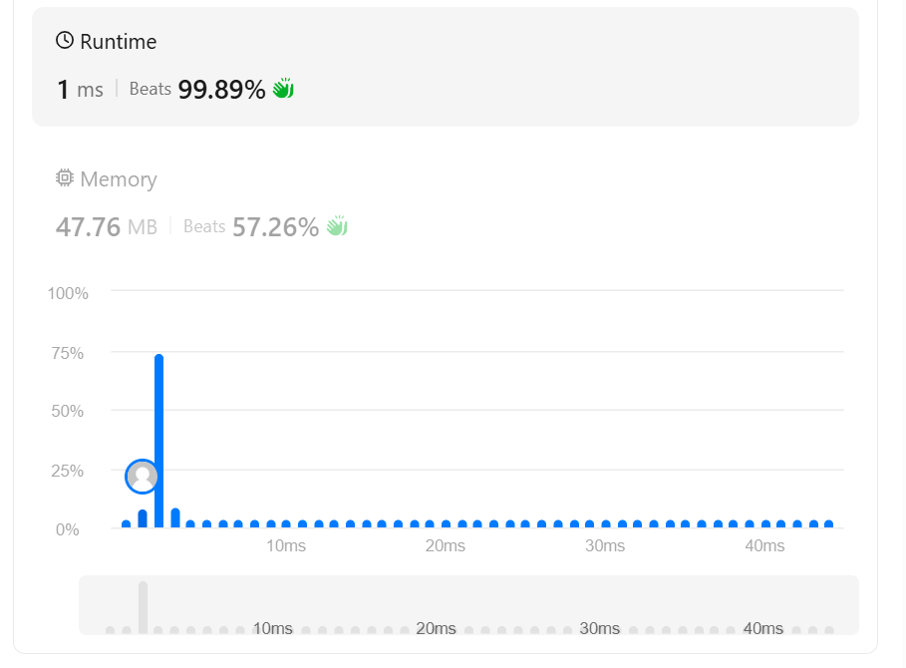
Task7:https://www.hackerrank.com/challenges/diagonal-difference/

Code:
import java.io.*;
import java.util.*;

public class Solution {

public static int diagonalDifference(List<List<Integer>> arr) {
int primarySum = 0;
int secondarySum = 0;
int n = arr.size();

for (int i = 0; i < n; i++) {
// Primary diagonal element is at [i][i]
primarySum += arr.get(i).get(i);

// Secondary diagonal element is at [i][n - 1 - i]
secondarySum += arr.get(i).get(n - 1 - i);
}

// Return absolute difference
return Math.abs(primarySum - secondarySum);
}

public static void main(String[] args) {
Scanner sc = new Scanner(System.in);
if (!sc.hasNextInt()) return;

int n = sc.nextInt();
List<List<Integer>> arr = new ArrayList<>();

for (int i = 0; i < n; i++) {
List<Integer> row = new ArrayList<>();
for (int j = 0; j < n; j++) {
row.add(sc.nextInt());
}
arr.add(row);
}

System.out.println(diagonalDifference(arr));
sc.close();
}
}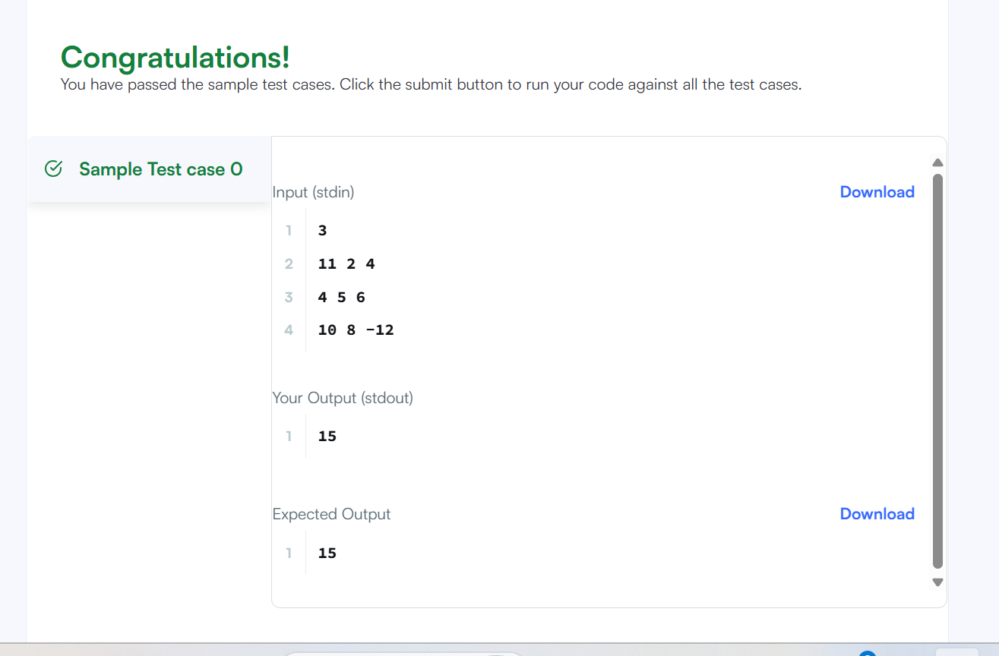
Task8:https://leetcode.com/problems/transpose-matrix/
Code:
class Solution {
public int[][] transpose(int[][] matrix) {
int rows = matrix.length;
int cols = matrix[0].length;

// The transposed matrix has dimensions swapped: cols x rows
int[][] result = new int[cols][rows];

for (int i = 0; i < rows; i++) {
for (int j = 0; j < cols; j++) {
result[j][i] = matrix[i][j];
}
}

return result;
}
}
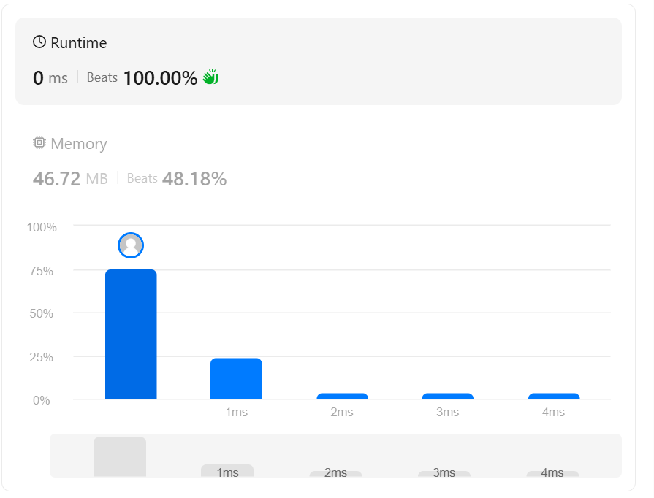
Task9:https://leetcode.com/problems/matrix-block-sum/
Code:

class Solution {
public int[][] matrixBlockSum(int[][] mat, int k) {
int m = mat.length;
int n = mat[0].length;

// Build 1-indexed 2D Prefix Sum array
int[][] pref = new int[m + 1][n + 1];
for (int i = 0; i < m; i++) {
for (int j = 0; j < n; j++) {
pref[i + 1][j + 1] = mat[i][j]
+ pref[i][j + 1]
+ pref[i + 1][j]
- pref[i][j];
}
}

int[][] ans = new int[m][n];

for (int i = 0; i < m; i++) {
for (int j = 0; j < n; j++) {
// Clamp sub-matrix boundaries to matrix dimensions
int r1 = Math.max(0, i - k);
int c1 = Math.max(0, j - k);
int r2 = Math.min(m - 1, i + k);
int c2 = Math.min(n - 1, j + k);

// Query sub-matrix sum in O(1)
ans[i][j] = pref[r2 + 1][c2 + 1]
- pref[r1][c2 + 1]
- pref[r2 + 1][c1]
+ pref[r1][c1];
}
}

return ans;
}
}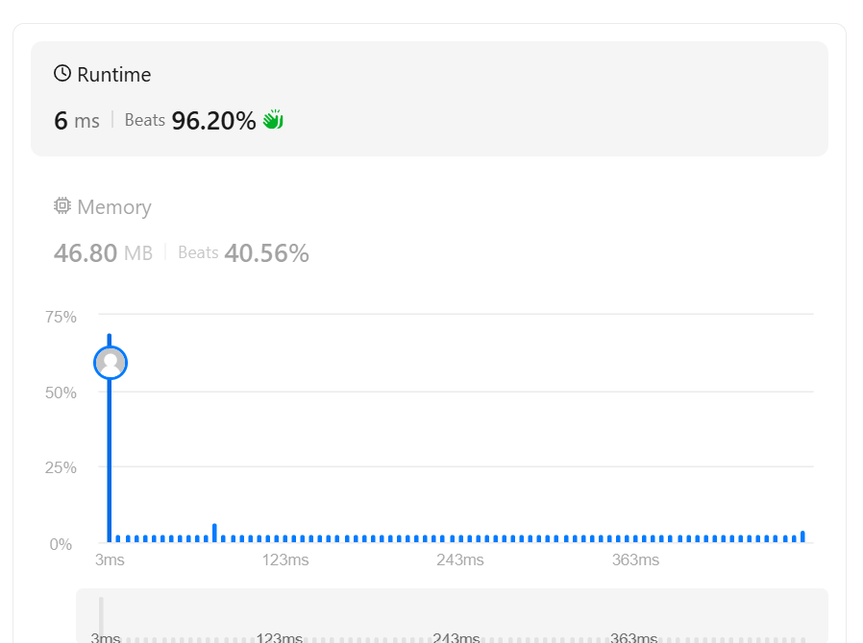
Task10:https://www.hackerrank.com/challenges/matrix-rotation-algo/problem
Code:
import java.io.*;
import java.util.*;

public class Solution {

public static void matrixRotation(List<List<Integer>> matrix, int r) {
int m = matrix.size();
int n = matrix.get(0).size();
int numLayers = Math.min(m, n) / 2;

for (int layer = 0; layer < numLayers; layer++) {
List<Integer> elements = new ArrayList<>();

// 1. Traverse Top Row (Left to Right)
for (int j = layer; j < n - layer; j++) {
elements.add(matrix.get(layer).get(j));
}
// 2. Traverse Right Column (Top to Bottom)
for (int i = layer + 1; i < m - layer - 1; i++) {
elements.add(matrix.get(i).get(n - 1 - layer));
}
// 3. Traverse Bottom Row (Right to Left)
for (int j = n - 1 - layer; j >= layer; j--) {
elements.add(matrix.get(m - 1 - layer).get(j));
}
// 4. Traverse Left Column (Bottom to Top)
for (int i = m - 2 - layer; i > layer; i--) {
elements.add(matrix.get(i).get(layer));
}

// Calculate effective rotations to avoid redundant full loops
int len = elements.size();
int shift = r % len;

// 5. Re-assign rotated values back into the matrix
int idx = 0;

// Top Row
for (int j = layer; j < n - layer; j++) {
matrix.get(layer).set(j, elements.get((idx + shift) % len));
idx++;
}
// Right Column
for (int i = layer + 1; i < m - layer - 1; i++) {
matrix.get(i).set(n - 1 - layer, elements.get((idx + shift) % len));
idx++;
}
// Bottom Row
for (int j = n - 1 - layer; j >= layer; j--) {
matrix.get(m - 1 - layer).set(j, elements.get((idx + shift) % len));
idx++;
}
// Left Column
for (int i = m - 2 - layer; i > layer; i--) {
matrix.get(i).set(layer, elements.get((idx + shift) % len));
idx++;
}
}

// Print the result matrix
StringBuilder sb = new StringBuilder();
for (int i = 0; i < m; i++) {
for (int j = 0; j < n; j++) {
sb.append(matrix.get(i).get(j)).append(j == n - 1 ? "" : " ");
}
sb.append("\n");
}
System.out.print(sb);
}

public static void main(String[] args) throws IOException {
BufferedReader br = new BufferedReader(new InputStreamReader(System.in));
String[] firstLine = br.readLine().trim().split("\\s+");
int m = Integer.parseInt(firstLine[0]);
int n = Integer.parseInt(firstLine[1]);
int r = Integer.parseInt(firstLine[2]);

List<List<Integer>> matrix = new ArrayList<>();
for (int i = 0; i < m; i++) {
String[] rowTokens = br.readLine().trim().split("\\s+");
List<Integer> row = new ArrayList<>();
for (int j = 0; j < n; j++) {
row.add(Integer.parseInt(rowTokens[j]));
}
matrix.add(row);
}

matrixRotation(matrix, r);
}
}